2023/24 NOTATION

NOTATION in music simply means writing things down so others can play or sing your composition.
Think of writing music as an author would write a novel. As an author you need a blank page and then you need to know the alphabet to start forming words, sentences and paragraphs. You form your story with a beginning, middle and end. You then refine your story using descriptive words, different paces of writing, colouring a phrase or character with descriptive words.
Writing music, or COMPOSING, is just the same.
- We need to know what our blank page looks like as a composer. It is called a STAVE (or STAFF, in America). This is just 5 horizonal lines where the notes are placed. They can be on lines or in the spaces.
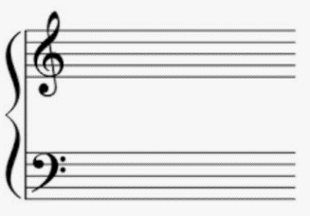
The symbols appearing at the beginning of the staves are CLEFS. These are the composer’s version of ‘Once upon a time…..’ The top is the TREBLE CLEF. This denotes that we are playing high pitch notes (above Middle C), eg. the right hand of the piano, instruments such as violins, flutes, recorder etc all play in the treble clef.
The other is the BASS CLEF, which denotes low pitch notes such as the left hand of the piano, double bass, trombone etc
- We need to know the names of the notes: ABCDEFG, that’s it! There are of course sharps and flats to consider but at this level we are just looking at the basics. Just seven notes.
- To start putting ‘words’ and ‘sentences’ together we need to know where we position the notes on the stave. To do this we split them into line notes and space notes.
Unfortunately, the position of the notes is different depending on which CLEF you are using, so we need to learn the rhymes for both treble and bass clefs. I think this term we’ll only cover the treble clef, so I’ll start there.
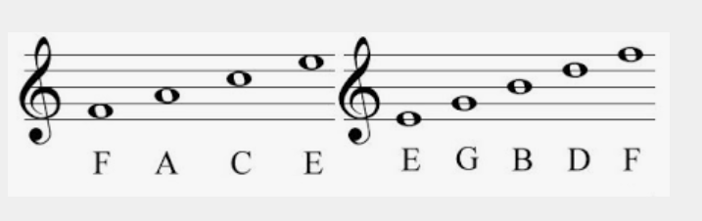
The easiest rhyme is for the space notes: DFACE rhymes with SPACE (There is a D that sits under the first line, couldn’t find a picture!)

The LINE notes mnemonic from bottom to top is: Every Good Boy Deserves Football
It has been taught like this for years, I actually find the children understand it better when we name the spaces and lines themselves with the rhymes or mnemonics, like so;
F ____________________________ A note placed on this line will ALWAYS be a ‘F’
D ____________________________
B ____________________________
G ____________________________
E ____________________________

E
C
A
F
D

____________________________
A note placed in this space will always be an ‘E’
____________________________
____________________________
____________________________
____________________________
Put together the notes look like this in the TREBLE CLEF
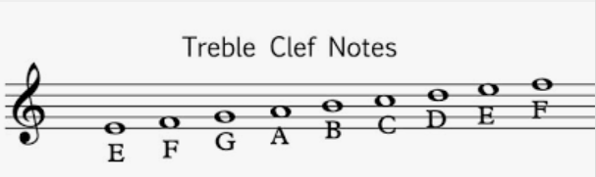
It is just a case of learning their positions and memorising them.
You can add lines to the 5-line stave. These are called LEDGER LINES. They are used to show notes of higher or lower pitch than the ones that live on the stave. The main one that is always used is the one for MIDDLE C, so called as it is in the middle of the piano keyboard and can be played both in the treble and bass clefs.
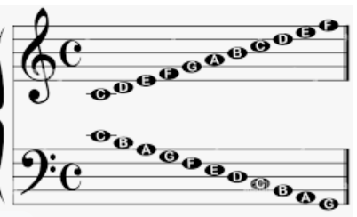

THE TWO MIDDLE Cs HERE ARE THE SAME PIANO KEY, see below.

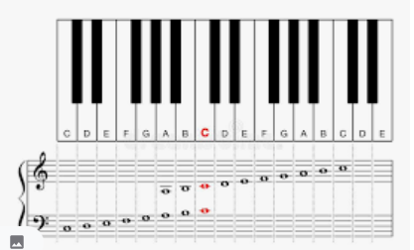
<<<<<<<<<<<<BASS CLEF><TREBLE CLEF >>>>>>>>>>>>>>>>>>

- We also need to know how long or short our beats are going to be – this will be covered under a DURATION crib sheet
- To start refining and shaping your musical story you use musical elements such as TEMPO (speed) and DYNAMICS (volume). All these are described using Italian words.

- Three simple TEMPO descriptions would be: SLOW = LENTO
MEDIUM = MODERATO
FAST = ALLEGRO
However, there are lots of words to describe TEMPO and also the style in which you should play the piece, for example, very fast = PRESTO, but it can also be VIVACE, the latter calls for a more ‘lively’ style of playing.

- Three simple DYNAMICS words would be: Quiet/soft = PIANO (pronounced pee-ar-no)
Speaking volume = MEZZO FORTE (pronounced met-so for-tay)
Loud = FORTE (pronounced for-tay)

