2023/24 DURATION

How long or short musical notes, sounds or silences are.

This is just a form of basic maths – different notes last for different lengths, these are then grouped together to make a piece of music. Each note has a corresponding REST or silence.

SEMIBREVE

MINIM

CROTCHET
QUAVER
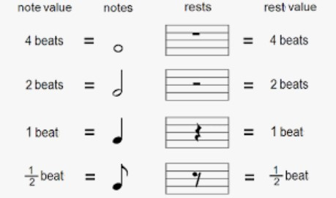
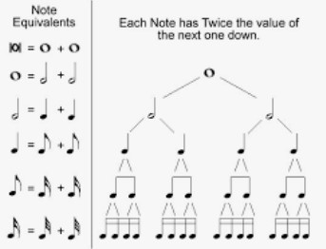
<< These notes are SEMIQUAVERS, half the value of a QUAVER
Quavers are usually grouped in twos 4s and semiquavers in 4s.

When we have a TIME SIGNATURE on the STAVE (the five lines on which music is written) it tells us how many beats you need to have in each BAR
Time signatures: 2/4 means 2 beats in bar, 3/4 means 3 and 4/4 means 4 – this is called SIMPLE TIME
So, for example if you had a time signature of 4/4 (as below) you could simply put a combination of these notes in a bar to make 4 beats, although ‘real’ music uses a huge mix of combinations and notes and rests, as below.
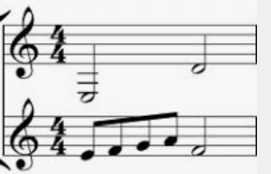
Either
EXAMPLE
2 MINIMS: 2 X 2 BEATS
= 4 beats
4 x ½ + 1 x 2 beat = 4
1 x SEMIBREVE = 1 X 4 BEATS =4 BEATS
2 X MINIMS 2 X 2 BEATS = 4
4 X CROTCHETS 4 X 1 BEAT = 4 BEATS
8 X QUAVERS 8 X ½ BEAT = 4
For younger children you can start with bugs or food to demonstrate long and short sounds – see bugs below:
