2023/24 DYNAMICS

DYNAMICS means VOLUME in music. We say LOUD and SOFT, rather than LOUD and QUIET

There are several dynamic markings in music which the children will learn, as below;
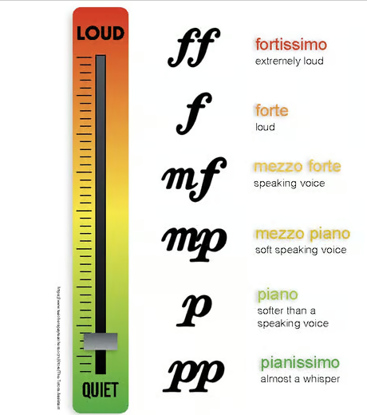

With the younger children I tend to use hand signals. Starting with pianissimo palm together and gradually moving out in degrees until hands are as far apart as possible for fortissimo.
For example, this would be PP – Pianissimo
This is good to use when asking them to sing loudly, but not shouting – “Sing Forte/ Mezzo Forte please”
Two other dynamic markings are Crescendo – getting gradually louder and either Diminuendo or Decrescendo, which mean getting gradually quieter/softer. The marks for these are as follows:
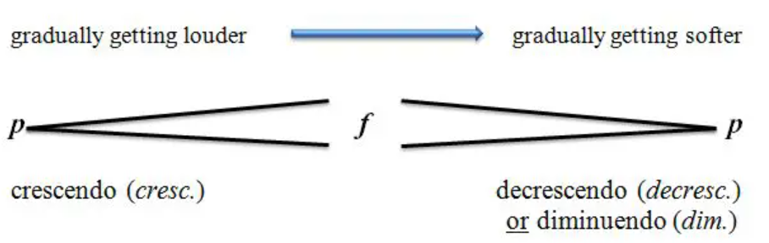
We also talk about silences in music (called RESTS in NOTATION). Why do we need silences in music, why do we need differing volumes in music? The answer is to give expression, convey a feeling, trick the listening into a false sense of security, shock them with an unexpected loud noise. This can lead on to a topic discussing film and television music. Listen to Delia Derbyshire – Dr. Who Theme

