2023/24 TIMBRE, TEXTURE, PITCH and SOUND WAVES

TEXTURE
Refers to the overall sound of a piece of music. It can be thick or thin, busy or sparse and so on. Texture is determined by how many instruments are playing, how many different parts there are and the TIMBRE of the instruments playing.
You can build up layers of rhythm, we call these POLYRHYTHMS. We practice this in class by using claves and creating different rhythms for each group to play over each other.
For reference, there are 4 types of texture but these are not studied at Primary level.
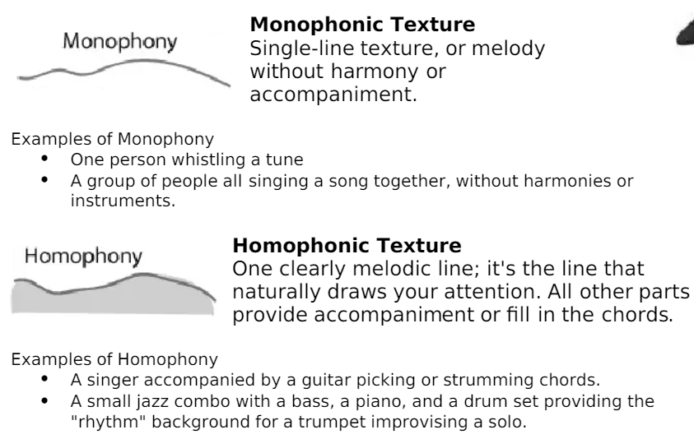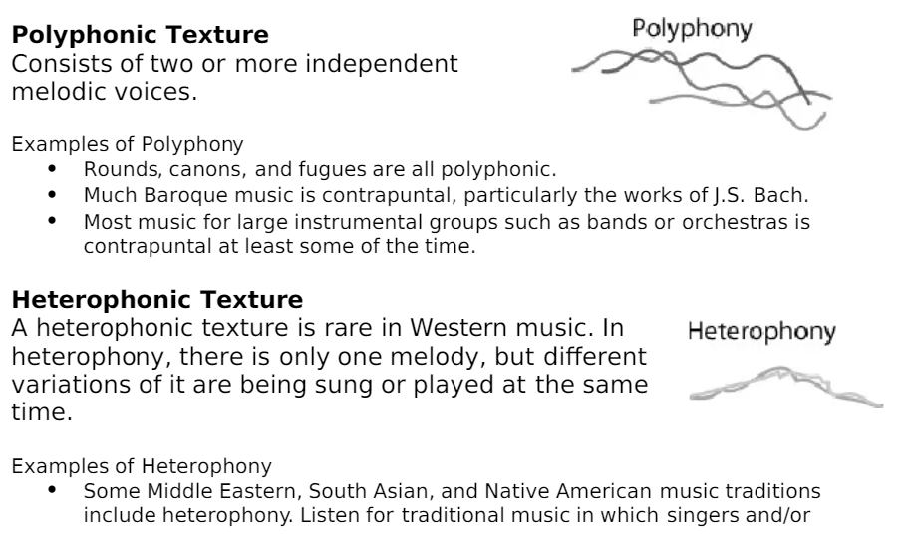

TIMBRE – pronounced TAMBER
This is the voice of the instrument or the colour of it’s sound. The timbre will differ depending on the material the instrument it made from. This is great to link with a science topic of Materials. For example, the note at a pitch of A will sound different if sung, played on a recorder or on a violin, The PITCH will be the same, but the tone or colour will sound different.

PITCH and SOUNDWAVES
High sounds, low sounds and everything in between!
On a stave (or Staff in America) the pitch of a note relates to where it is placed on a stave.
High notes sit high, low notes sit low.
High pitch instruments are usually small and/or thin or short, like a violin, piccolo, recorder, or the right hand side of a piano, as the string the hammers hit are thinner and shorter. These instruments create fast sound waves and tall soundwaves.
Low pitch instruments are large, wide and/or thick, like a Double Bass, Tuba or Bassoon. These instruments create wide and slower sound waves.
Use Google Chrome Music Lab ‘Oscillators’ to demonstrate this. https://musiclab.chromeexperiments.com/Oscillators/
We know that as we grow, out hearing changes. Use Chrome Music Lab to demonstrate this using ‘Spectrogram’ https://musiclab.chromeexperiments.com/Spectrogram/
Children can hear the very high pitches, over 21 year olds cannot!
This topic can link to SOUND and THE AUDITORY SYSTEM. We talk about sound as a VIBRATION

